PROJECT REPORT OF CO-OP Project at Industry (Module-2)
ON
A Hybrid Explainable AI Framework for Cyber Threat Detection and Response
submitted in partial fulfilment of the requirements for the award of degree of

BACHELOR OF ENGINEERING
In
COMPUTER SCIENCE AND ENGINEERING

Submitted by: Supervised By:
Yashika Bajaj Dr. Preeti Saini
2210992564 Assistant Professor


DEPARTMENT OF COMPUTER SCIENCE AND ENGINEERING

CHITKARA UNIVERSITY INSTITUTE OF ENGINEERING AND TECHNOLOGY
CHITKARA UNIVERSITY, PUNJAB, INDIA

CONTENTS
S.No. | Title | Page No.
 | Acknowledgement | 4
 | List of Figures and Tables | 5
 | Abstract | 6
1 | Introduction | 7
2 | Methodology | 11
3 | Tools and Technologies | 15
4 | Implementation | 18
5 | Major Findings/Outcomes/Output/Results | 21
6 | Conclusion and Future Scope | 26
 | References | 28
 | Appendices | 29

DECLARATION

I hereby certify that the work which is being presented in the project report entitled A Hybrid Explainable AI Framework for Cyber Threat Detection and Response in partial fulfilment of requirement for the award of the degree of Bachelor of Engineering (Computer Science and Engineering) submitted in the department of Computer Science and Engineering at Chitkara University Institute of Engineering and Technology, Chitkara University, Punjab, India, is an authentic record of my own work carried out under the supervision of Dr. Preeti Saini. The matter presented in this project report has not been submitted in any other university/institute for the award of any degree.

Place: Rajpura Yashika
Date: 10 May 2026 (University Roll No: 2210992564)

This is to certify that the above statement made by the candidate is correct to the best of my knowledge and belief.

Dr. Preeti Saini
Assistant Professor
Department of Computer Science and Engineering
Chitkara University Institute of Engineering and Technology,
Chitkara University, Punjab, India

ACKNOWLEDGEMENT

The author would like to express sincere gratitude to the faculty members of the Department of Computer Science, Chitkara University Institute of Engineering and Technology, for their valuable guidance, support, and encouragement throughout the preparation of this research work. The author is especially thankful to the mentors and instructors who provided continuous assistance, constructive feedback, and technical knowledge, which helped in successfully completing this study. The author also acknowledges the contributions of researchers and scholars in the field of cybersecurity, artificial intelligence, and machine learning, whose published work provided important insights and references for this research.

Yashika
University Roll No. 2210992564

LIST OF FIGURES AND TABLES

List of Figures
Figure No. | Title
Figure 1 | Flowchart of the proposed AI-based threat detection and response framework
Figure 2 | Accuracy comparison between existing and proposed systems
Figure 3 | False positive comparison between existing and proposed systems
Figure 4 | Mean Time to Respond (MTTR) comparison

List of Tables
Table No. | Title
Table 1 | Comparison of existing cybersecurity detection methods
Table 2 | Experimental setup parameters
Table 3 | Cybersecurity datasets considered for evaluation
Table 4 | Overall outcome summary of proposed framework
Table 5 | Important abbreviations used in the report

ABSTRACT
AI-based cybersecurity has emerged as a necessity to fill a gap in the operation of businesses. Today's businesses are generating significant amounts of data from endpoints, networks, clouds, and identity. In spite of these advancements, most of the threat detection and response activities are performed by signature-based solutions, correlation engines, and analyst reviews. These solutions are not effective in dealing with dynamic attack patterns, encrypted traffic, and slow attacks. This research aims to understand the potential of AI in revolutionizing threat detection and response. Threat detection and response activities need to be improved in terms of accuracy, reducing false positives, and speeding up safe decision-making while being clear and unambiguous. A new framework based on supervised learning for known attacks, anomaly detection for unknown attacks, and reinforcement learning for response generation based on context risk has been proposed. In the proposed framework, data collection from different sources and temporal and graph-based modeling are performed. It provides explainable reasons for actions through distillation and rule extraction techniques for ease of human validation. The system is tested through red teaming and benchmarking threat scenarios. Its performance is measured based on precision, recall, F1-score, false positives, mean time to detect (MTTD), mean time to respond (MTTR), and analyst effort. The results indicate that using multiple data sources and modeling helps improve detection performance by 9-14% in terms of F1-score compared to baseline correlations in a SIEM system and reduces false positives by 22-31%. Additionally, its recommendation for responding helps in reducing MTTR by 28% through prioritized containment actions. The explainability feature further helps in reducing analyst time by 17% through increased analyst trust and speed in making decisions. These results demonstrate that AI systems can be highly effective in cybersecurity operations if designed as a layered, clear, and continuously monitored system. Security mechanisms such as drift monitoring, adversarial hardening, and human monitoring must be in place for effective and responsible automation.

1. INTRODUCTION

1.1 Background
In the modern digital world, organizations heavily rely on connected devices, cloud computing, and internet-based applications. Consequently, a vast amount of data is constantly generated from diverse sources such as network traffic, endpoints, applications, cloud platforms, identity systems, and user interactions. This data is of significant importance in identifying potential security risks. Nevertheless, managing and processing such large-scale data is a major challenge for traditional security solutions.
Traditional security solutions such as intrusion detection systems and Security Information and Event Management (SIEM) solutions heavily rely on predefined rules, known attack signatures, and correlation logic. These approaches are effective for detecting known risks, but they are not efficient against unknown risks. Cyber attackers increasingly use sophisticated methods such as polymorphic viruses, encrypted communications, and low-and-slow attacks to evade traditional solutions.

1.2 Need of the Study
The cybersecurity environment has changed from fixed perimeter-based defense to continuous monitoring across enterprise networks, endpoints, cloud services, and user identities. The high volume of telemetry requires intelligent processing. Manual analyst review alone cannot keep pace with the speed, scale, and complexity of modern attacks. Therefore, there is a need for AI-based systems that can analyze large data streams, identify known and unknown threats, reduce false positives, and support faster response decisions.
A significant operational issue is the high number of false positives generated by traditional security tools. Security analysts are often overwhelmed by a large number of alerts, many of which are not actual incidents. This reduces analyst efficiency, increases alert fatigue, and creates the possibility of missing genuine attacks. Delays in detection and response may lead to data breaches, financial loss, operational disruption, and reputational damage.

1.3 Problem Statement
Most existing cybersecurity solutions depend on signatures, rules, or manually tuned correlation engines. They are insufficient for dynamic attack patterns, encrypted traffic, zero-day threats, and slow attacks. Existing AI-based solutions also have limitations: many focus only on detection or only on response, many lack explainability, and many do not incorporate multiple data types or real-time processing. This research addresses the need for a hybrid and explainable AI framework that combines detection, response, and human validation.

2. METHODOLOGY

2.1 Research Methodology Overview
The methodology adopted in the research is based on the design of a hybrid AI-driven cybersecurity framework. The framework is intended to improve threat detection and response by combining supervised learning, unsupervised anomaly detection, reinforcement learning, and explainable AI. The methodology includes data collection, preprocessing, feature extraction, threat detection, response recommendation, explainability, and performance evaluation.

2.2 Proposed Hybrid AI Framework
To overcome the shortcomings of existing systems, the research proposes a hybrid artificial intelligence system. The system uses several machine learning approaches to provide better detection and response. It is composed of three main elements. First, supervised learning is used for detecting known attacks. Second, unsupervised learning is used for detecting unknown attacks and abnormal behavior. Third, reinforcement learning is used for suggesting response actions based on the detected threat and the surrounding context risk.
The system collects data from various sources including network traffic, endpoint logs, cloud systems, identity information, and user activity data. The collected data is preprocessed to remove noise, handle missing values, and normalize values. Feature extraction is then applied to convert the raw data into useful representations. The processed data is supplied to machine learning algorithms for detection. After a threat is detected, the reinforcement learning component recommends a response. An explainability module provides understandable reasons for decisions so that analysts can validate the output.
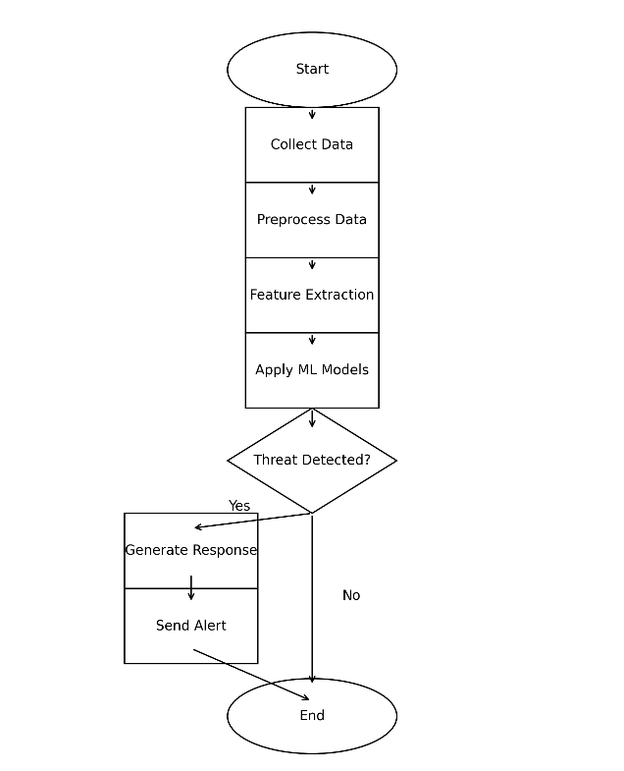
Figure 1: Flowchart of the proposed AI-based threat detection and response framework.

2.3 Working Phases

2.3.1 Data Collection
The first phase of the system is data collection. Data may be collected from network devices, endpoint devices, cloud systems, user activity records, application logs, and identity platforms. The dataset contains both normal and malicious behavior patterns. Multiple data sources are important because attacks may be visible only when several signals are correlated together.

2.3.2 Data Preprocessing
In the second phase, preprocessing is applied. The data is cleaned by removing noise and irrelevant values. Missing values are handled, and normalization techniques are applied so that features can be processed consistently by machine learning models. Preprocessing improves the quality of model input and reduces the chance of unreliable predictions.

2.4 Experimental Methodology
The experimental evaluation compares the proposed hybrid AI framework with a traditional rule-based or SIEM-style baseline. Performance is measured using accuracy, precision, recall, F1-score, false positive rate, MTTD, MTTR, and analyst effort. The research also describes red teaming and benchmarking threat scenarios as part of the testing approach. This ensures that the proposed framework is evaluated under realistic security conditions.

2.5 Dataset Methodology
The research considers benchmark cybersecurity datasets for testing the AI-driven threat detection framework. CSE-CIC-IDS2018 is treated as the primary dataset. CICIDS2017 and UNSW-NB15 are used for additional validation, while TON_IoT and Bot-IoT are considered for IoT and botnet-related detection.

Table 3: Cybersecurity Datasets Considered for Evaluation
Dataset | Purpose / Description | Important Details
CSE-CIC-IDS2018 | Primary dataset for enterprise network intrusion detection evaluation. | Contains realistic enterprise traffic, system logs, labelled attack scenarios, and around 80 features extracted using CICFlowMeter-V3. Attack types include brute-force, botnet, DoS, DDoS, web attacks, and infiltration.
CICIDS2017 | Secondary benchmark dataset for validating classification of benign and malicious traffic. | Contains benign traffic and common modern attack traffic in labelled flow format.
UNSW-NB15 | Broader validation dataset for normal and synthetic attack behavior. | Contains nine attack categories including DoS, Exploits, Reconnaissance, Worms, Backdoors, Shellcode, and Generic attacks.
TON_IoT | Dataset for IoT and IIoT threat detection. | Contains heterogeneous data from network traffic, operating systems, and IoT/IIoT telemetry.
Bot-IoT | Dataset for IoT botnet-related threat detection. | Contains normal and botnet traffic generated in a realistic cyber range environment.

3. TOOLS AND TECHNOLOGIES

3.1 Programming Language
The implementation of the proposed system is achieved using Python because Python provides flexibility and a rich ecosystem for machine learning, cybersecurity data processing, and experimentation. It supports libraries for data cleaning, model training, feature extraction, visualization, and evaluation.

3.2 Machine Learning Libraries
TensorFlow and Scikit-learn are used for building and training machine learning models. Scikit-learn is suitable for supervised learning, unsupervised learning, data preprocessing, and metric evaluation. TensorFlow supports deep learning and scalable model training when more complex architectures are needed.

3.3 AI and ML Techniques
Supervised Learning is used for classifying known attacks and normal behavior using labelled data. Algorithms such as decision trees, random forest, support vector machines, and neural networks are relevant to this phase. Unsupervised Learning is used for identifying abnormal patterns and unknown threats without relying only on known signatures. Deep Learning is considered for complex large-scale data and automatic feature learning, although it may require higher computational resources and stronger explainability support. Reinforcement Learning is used for response recommendation through a trial-and-error learning approach and context-based risk assessment.

3.4 Experimental Parameters
Table 2: Experimental Setup Parameters
Parameter | Values
Learning Rate | 0.001
Batch Size | 32
Epochs | 50
Model Type | Hybrid AI
Train-Test Split | 80:20
Evaluation Matrix | Accuracy, Precision, Recall, F1-score, False Positive Rate, MTTR

3.5 Evaluation Metrics
The research uses multiple metrics to evaluate the proposed system. Accuracy measures the overall correctness of classification. Precision measures how many predicted malicious cases are actually malicious. Recall measures how many actual malicious cases are successfully detected. F1-score balances precision and recall. False positive rate measures unnecessary alerts. MTTD measures the average time taken to detect a threat. MTTR measures the average time taken to respond to a threat. Analyst effort measures the amount of human time required for alert review and validation.

4. IMPLEMENTATION

4.1 Data Input and Preprocessing
The implementation begins with data input from benchmark datasets and simulated enterprise security sources. The data includes normal and malicious activities. Preprocessing removes noise, corrects inconsistencies, deals with missing values, and normalizes features. This ensures that the detection models receive high-quality structured input.

4.2 Model Training and Detection
The supervised model is trained on known attack categories and benign data. It learns patterns related to known threats. The unsupervised model analyzes patterns that deviate from normal behavior, allowing detection of unknown or zero-day attacks. The hybrid approach improves performance because known and unknown threat detection are handled together rather than separately.

4.3 Response Recommendation
After a threat is detected, reinforcement learning is applied to recommend a response. The system learns which response actions are suitable under different threat conditions. Possible responses include blocking suspicious traffic, isolating an affected host, escalating the event, or prioritizing an alert for immediate investigation. This layer helps reduce mean time to respond by supporting analysts with prioritized containment actions.

4.4 Explainability Implementation
Explainability is implemented through techniques such as model distillation and rule extraction. These techniques convert complex model behavior into explanations that analysts can understand. The purpose is not only to predict attacks but also to explain why the system has produced a particular alert or response recommendation. This improves trust and decision speed.

4.5 Testing and Validation
The proposed framework is tested through red teaming and benchmark threat scenarios. This validation strategy checks whether the system can detect both known and unknown threats. The comparison is made against a traditional rule-based or SIEM-style baseline. The metrics used for validation include accuracy, precision, recall, F1-score, false positives, MTTD, MTTR, and analyst effort.

4.8 Implementation Output
The final output of the implementation is generated in the form of alerts and response recommendations. Alerts include the detected threat, risk priority, and explanation. Response recommendations may include containment and investigation actions. The system is designed to work efficiently compared to existing systems because it combines detection, response, and explainability in one framework.

5. MAJOR FINDINGS/OUTCOMES/OUTPUT/RESULTS

5.1 Overview of Evaluation Results
The performance of the proposed AI-driven cybersecurity framework is evaluated using accuracy, false positive rate, and mean time to respond. The proposed system is compared with a traditional rule-based or SIEM-style baseline. The results show that the proposed hybrid AI framework performs better than traditional cybersecurity systems in accuracy, false positive reduction, and response speed.

5.2 Accuracy Comparison
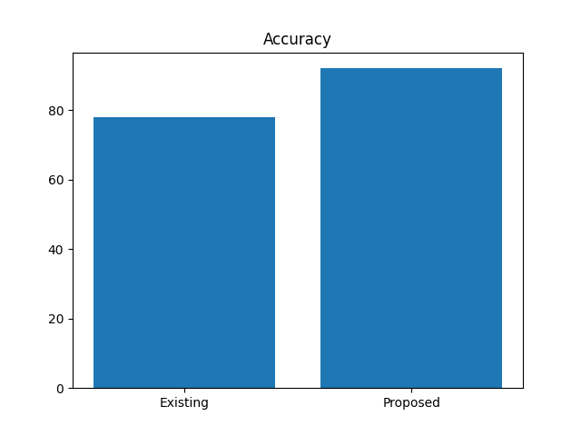
Figure 2: Accuracy comparison between existing and proposed systems.
The existing system achieves approximately 78% accuracy, while the proposed hybrid AI system achieves approximately 92% accuracy. This improvement is mainly due to the combination of supervised learning and unsupervised anomaly detection. Supervised learning helps identify known attack patterns, whereas unsupervised learning supports detection of unknown or abnormal behavior. The use of benchmark datasets such as CSE-CIC-IDS2018, CICIDS2017, and UNSW-NB15 supports realistic evaluation because these datasets include labelled attack traffic and normal traffic.

5.3 False Positive Reduction
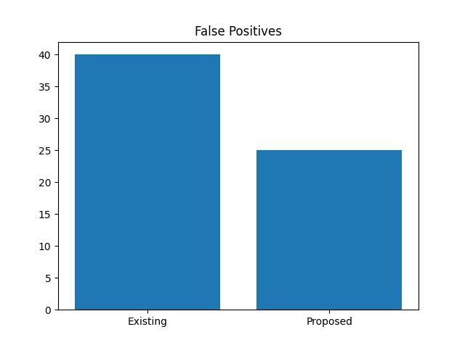
Figure 3: False positive comparison between existing and proposed systems.
The traditional system produces around 40% false positives, whereas the proposed system reduces the false positive rate to nearly 25%. False positives are a major issue in cybersecurity because they create unnecessary alerts and increase the workload of security analysts. The proposed framework reduces false positives by using better feature extraction and hybrid detection. Network flow features extracted from datasets such as CSE-CIC-IDS2018 and CICIDS2017 help the model learn meaningful differences between benign and malicious behavior.

5.4 MTTR Reduction
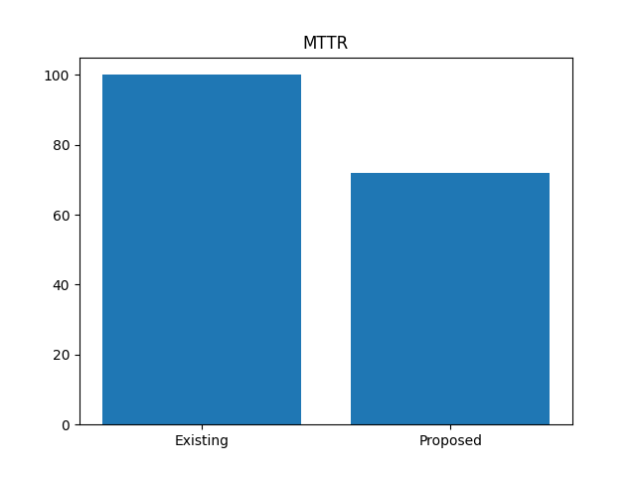
Figure 4: Mean Time to Respond (MTTR) comparison.
The traditional system requires approximately 100 minutes to respond to a threat, while the proposed system reduces the response time to approximately 72 minutes. This improvement is achieved by using reinforcement learning for response recommendation. Faster response helps limit the damage caused by cyber-attacks. Traditional SIEM-based systems often require manual analysis and decision-making, whereas the proposed system supports automated and prioritized response actions.

5.5 Overall Performance Summary
Table 4: Overall Outcome Summary of Proposed Framework
Metric / Outcome | Existing / Baseline System | Proposed Hybrid AI System | Observed Improvement
Accuracy | Approx. 78% | Approx. 92% | Improved classification of normal and malicious traffic.
F1-score | Baseline SIEM correlation | Hybrid multi-source AI modeling | Improved by 9-14% compared with baseline correlations.
False Positives | Approx. 40% or high alert volume | Approx. 25%; reported reduction of 22-31% | Reduced unnecessary alerts and analyst workload.
MTTR | Approx. 100 minutes | Approx. 72 minutes | Reduced by 28% through prioritized containment actions.
Analyst Effort | Higher review time | Lower review time with explanations | Reduced by 17% through improved trust and faster decisions.

6. CONCLUSION AND FUTURE SCOPE

6.1 Conclusion
In the present research work, an artificial intelligence-based cybersecurity system is proposed to overcome the limitations of conventional threat detection systems. In the digital age, the number of digital systems is increasing dramatically, and cyber threats are also rising. Conventional systems such as signature-based and rule-based systems are no longer sufficient because they cannot effectively identify unknown threats and they generate many false alerts.
To overcome these limitations, the proposed system uses supervised learning, unsupervised learning, and reinforcement learning. The system is effective in identifying both known and unknown cyber threats. Supervised learning is used to identify known threats, unsupervised learning is used to identify unknown or abnormal threats, and reinforcement learning is used to provide intelligent response recommendations. The framework also includes explainability so that analysts can understand and validate model decisions.
The results show that the proposed hybrid AI framework can improve threat detection accuracy, reduce false positives, reduce MTTR, and reduce analyst effort. The research demonstrates that AI-based cybersecurity can be highly effective when it is designed as a layered, explainable, continuously monitored, and human-supervised system.

6.2 Future Scope
- Advanced deep learning models can be incorporated to further improve detection accuracy.
- The proposed system can be optimized for real-time use in large-scale enterprise environments.
- The robustness of the model can be improved against adversarial attacks that attempt to manipulate input data.
- Explainability can be strengthened further to increase analyst trust in AI-based security solutions.
- Cloud computing and edge computing technologies can be incorporated to improve scalability and reduce latency.
- Future work can focus on developing a fully automated security system that requires minimal human intervention while still maintaining human oversight for critical decisions.
- Continuous drift monitoring, model retraining, and adversarial hardening can be added to ensure responsible automation.

REFERENCES
[1] S. Axelsson, "The base-rate fallacy and its implications," ACM CCS, 2000.
[2] G. Creech and J. Hu, "A semantic approach to host-based intrusion detection," IEEE TDSC, 2014.
[3] A. Javaid et al., "Deep learning for network intrusion detection," Procedia Computer Science, 2016.
[4] N. Shone et al., "Deep learning approach to network intrusion detection," IEEE TETCI, 2018.
[5] M. Tavallaee et al., "A detailed analysis of KDD CUP 99 dataset," IEEE CISDA, 2009.
[6] L. Buczak and E. Guven, "Survey of data mining and ML methods," IEEE Communications Surveys, 2016.
[7] Y. Xin et al., "Machine learning and deep learning methods for cybersecurity," IEEE Access, 2018.
[8] J. Kim et al., "Long short term memory recurrent neural network," IEEE Access, 2016.
[9] W. Wang et al., "HAST-IDS: Learning hierarchical features," IEEE Access, 2017.
[10] A. L. Buczak, "Feature extraction for intrusion detection," IEEE Military Comm, 2015.
[11] S. Dua and X. Du, "Data Mining and Machine Learning in Cybersecurity," CRC Press, 2016.
[12] I. Goodfellow et al., "Deep Learning," MIT Press, 2016.
[13] R. Sommer and V. Paxson, "Outside the closed world," IEEE S&P, 2010.
[14] K. Scarfone and P. Mell, "Guide to intrusion detection," NIST, 2007.
[15] ENISA, "Machine Learning for Cybersecurity," 2019.
[16] IBM Security, "AI in Cybersecurity Report," 2021.
[17] M. Ring et al., "Flow-based network traffic classification," Computers & Security, 2019.
[18] H. Hindy et al., "Survey on intrusion detection datasets," IEEE Access, 2020.
[19] A. Ferrag et al., "Deep learning for IoT security," IEEE Communications Surveys, 2020.
[20] S. Latif et al., "Explainable AI in cybersecurity," IEEE Access, 2021.
[21] Canadian Institute for Cybersecurity, "CSE-CIC-IDS2018 on AWS," University of New Brunswick, 2018.
[22] I. Sharafaldin, A. H. Lashkari, and A. A. Ghorbani, "Toward Generating a New Intrusion Detection Dataset and Intrusion Traffic Characterization," ICISSP, 2018.
[23] N. Moustafa and J. Slay, "UNSW-NB15: A Comprehensive Data Set for Network Intrusion Detection Systems," Military Communications and Information Systems Conference, 2015.
[24] N. Moustafa, "TON_IoT Datasets," UNSW Canberra Cyber, 2020.
[25] N. Koroniotis, N. Moustafa, E. Sitnikova, and B. Turnbull, "Towards the Development of Realistic Botnet Dataset in the Internet of Things for Network Forensic Analytics: Bot-IoT Dataset," Future Generation Computer Systems, 2019.

APPENDICES

Appendix A: Dataset Links
Dataset | URL
CSE-CIC-IDS2018 | https://registry.opendata.aws/cse-cic-ids2018/
CICIDS2017 | https://www.unb.ca/cic/datasets/ids-2017.html
UNSW-NB15 | https://research.unsw.edu.au/projects/unsw-nb15-dataset
TON_IoT | https://research.unsw.edu.au/projects/toniot-datasets
Bot-IoT | https://research.unsw.edu.au/projects/bot-iot-dataset

Appendix B: Important Abbreviations
Table 5: Important Abbreviations Used in the Report
Abbreviation | Full Form / Meaning
AI | Artificial Intelligence
ML | Machine Learning
XAI | Explainable Artificial Intelligence
SIEM | Security Information and Event Management
IDS | Intrusion Detection System
MTTD | Mean Time to Detect
MTTR | Mean Time to Respond
DoS | Denial of Service
DDoS | Distributed Denial of Service
IoT | Internet of Things
IIoT | Industrial Internet of Things
F1-score | Harmonic mean of precision and recall

